📖 Event Management System in Salesforce
(Implemented using Salesforce Build → Objects, Flows, Dashboards, and Automation)
1️⃣ Event List Page 🗓️✨

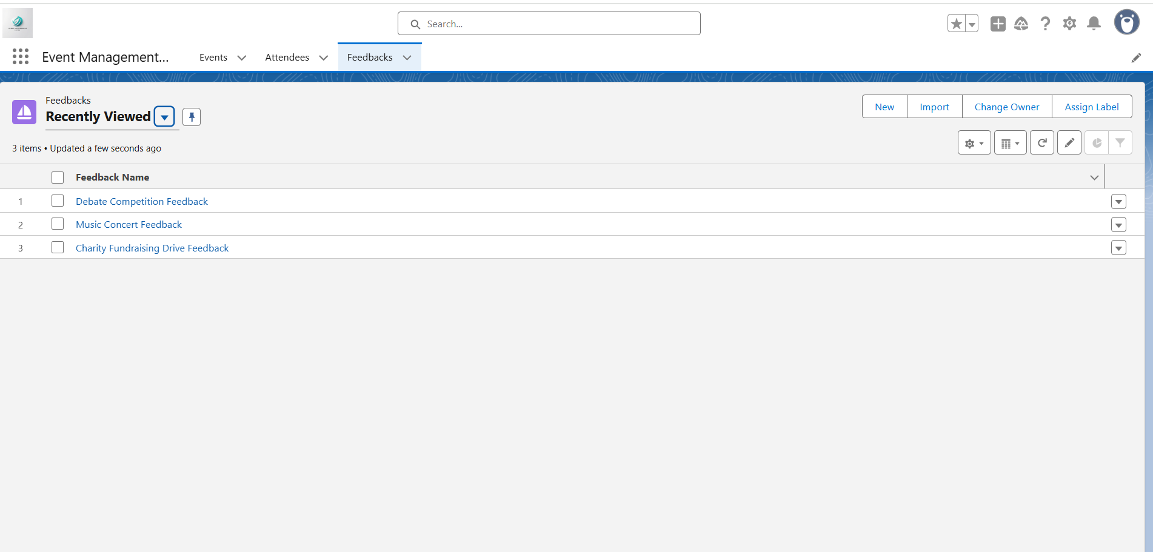

📌 Purpose: This is the entry point of the system. Students can see all upcoming and available events at a glance.
🔹 Key Features:
Displays a list of all active events stored in Salesforce.
Shows important details like:
Event Name 🎉 → Example: “Tech Fest 2025”
Date & Time 🕒 → Example: “16th August, 11:00 AM”
Venue / Location 📍 → Example: “Auditorium Hall”
Description 📝 → Short intro about the event.

🔹 Behind the Scenes (Configuration):
A Custom Object Event__c was created in Salesforce.
Fields include: Event Name, Date, Time, Venue, Description.
A List View was configured so students can browse events.
💡 Impact: Makes it easy for students to explore and select events of interest without contacting organizers.
2️⃣ Event Registration Form 📝🎟️
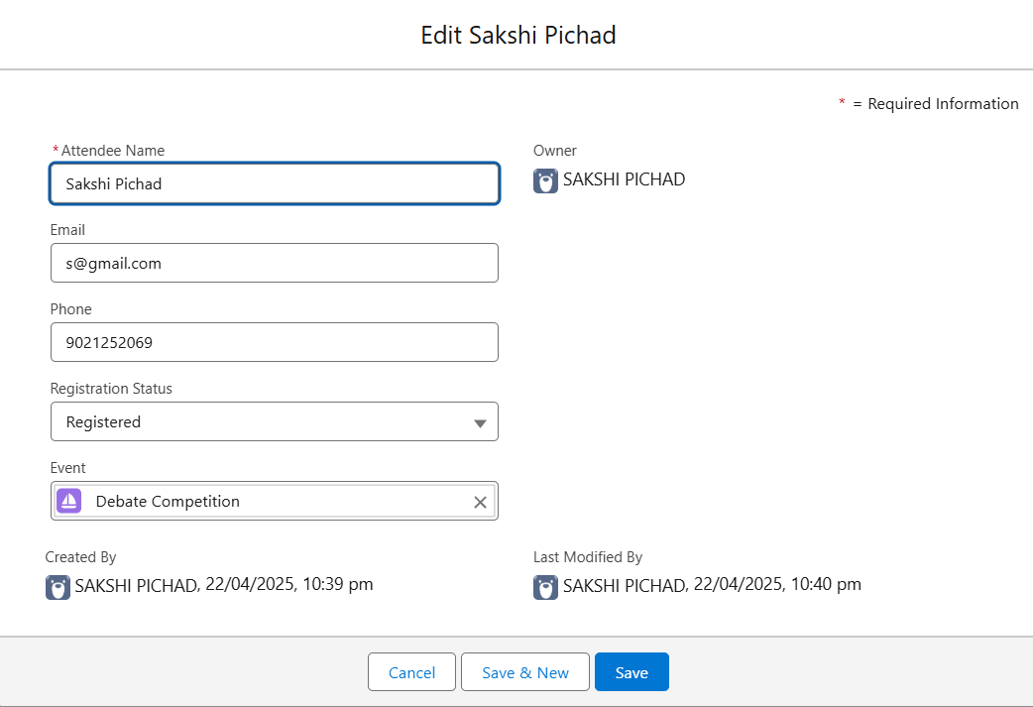

📌 Purpose: Enables students to register for an event quickly and easily.
🔹 Fields Captured:
👩‍🎓 Student Full Name
📧 Email Address (used for notification)
🎟️ Event Selection (lookup to Event__c)
📞 Contact Number
✍️ Additional Notes (optional feedback or request)
🔹 Behind the Scenes (Configuration):
A Custom Object Registration__c was created.
Lookup relationship to Event__c ensures each registration is tied to a specific event.
A Record Page & Quick Action Button (“Register Now”) were built to capture student details.
🔹 Automation:
When the form is submitted → Salesforce automatically creates a Registration record and links it to the chosen event.
💡 Impact: Students register on their own without manual intervention. Admins instantly see the new entries.

3️⃣ Student Dashboard 👩‍🎓📊

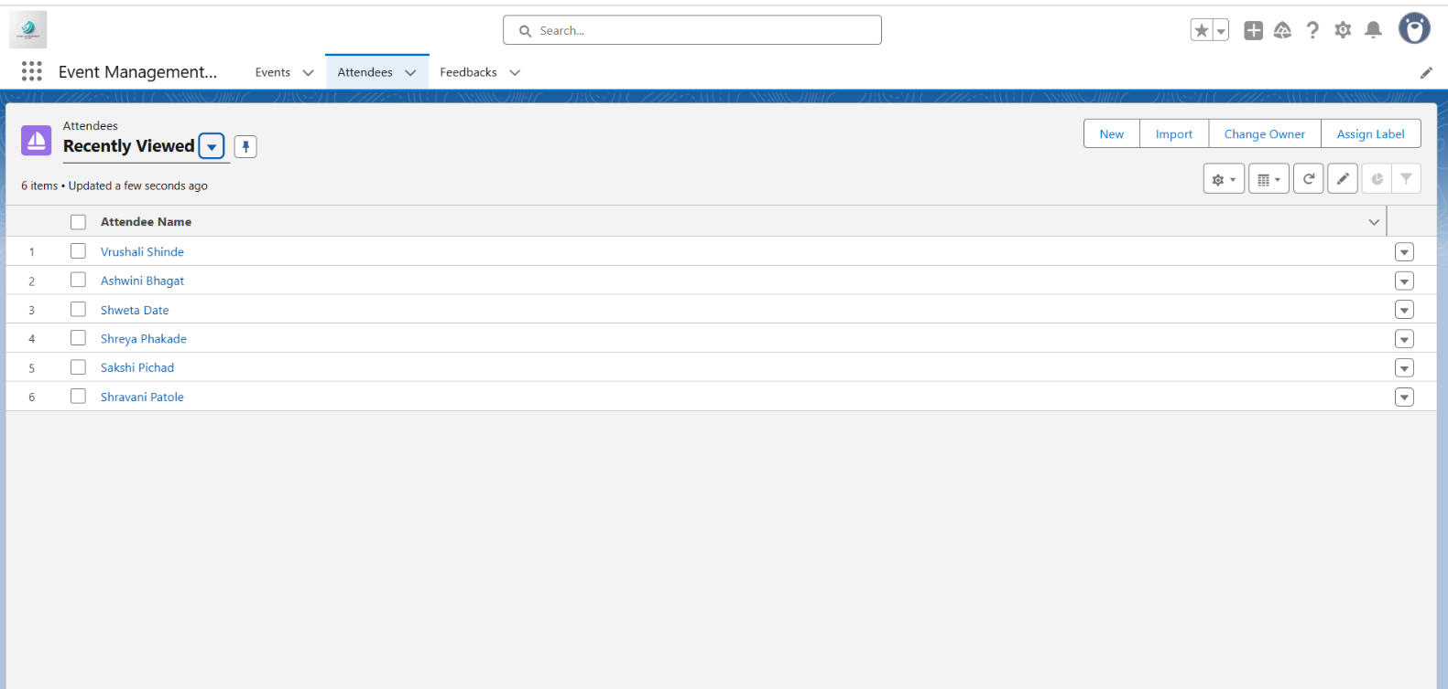

📌 Purpose: Provides a personal space where each student can view their registrations.
🔹 Features for Students:
List of all events they have registered for.
Quick access to event details (date, venue, description).
Easy way to confirm which events they are attending.
🔹 Behind the Scenes (Configuration):
Created a Custom Report filtered by student’s email.
Added a Dashboard Component that pulls live registration data.
💡 Impact: Students feel in control of their event schedule and don’t need to remember details separately.

4️⃣ Admin Dashboard 🛠️👨‍💻

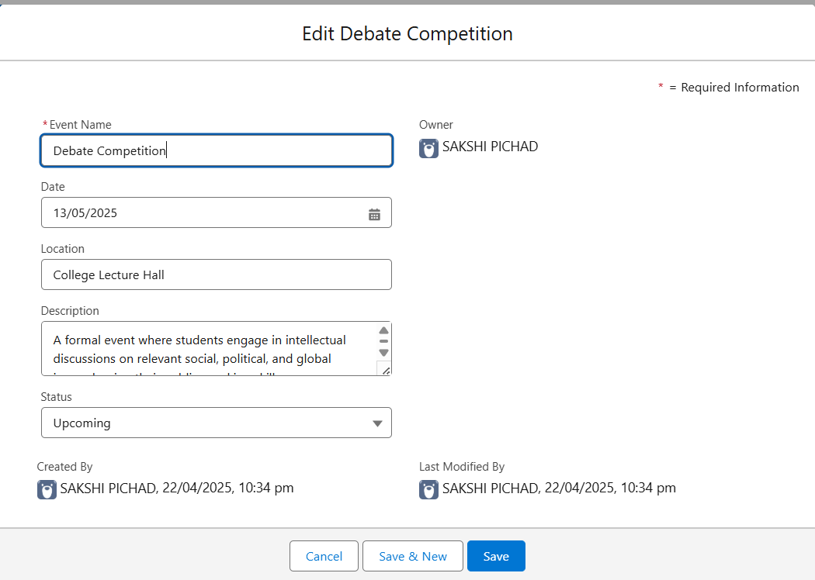

📌 Purpose: Gives event organizers a control center to monitor events and participants.

🔹 Features for Admins:
View all events with participant count.
Drill down into each event → See list of registered students.
Edit event details (venue/time) directly if changes occur.
Monitor event popularity (which events have max registrations).
🔹 Behind the Scenes (Configuration):
Report Types combining Event__c and Registration__c.
Admin Dashboard with charts:
📊 Bar Chart → Registrations per Event.
📈 Line Graph → Trend of registrations over time.
🔢 KPI Metrics → Total registrations today, this week, etc.
💡 Impact: Admins don’t need Excel sheets or manual tracking — Salesforce dashboard shows everything live.

5️⃣ Automation Flow ⚡🔄
📌 Purpose: Automates the linking process and reduces human errors.
🔹 Flow Configuration:
Type: Record-Triggered Flow
Trigger: When a Registration record is created.

Steps:
Flow captures the selected Event.
Links registration to the correct Event__c record.

🔹 Why Flow?
No Apex code required.
100% declarative (point-and-click).
Easy to maintain and modify.
💡 Impact: No need for manual entry corrections. Every registration is perfectly mapped to its event.

6️⃣ Email Notification 📧📬 (Implemented ✅)

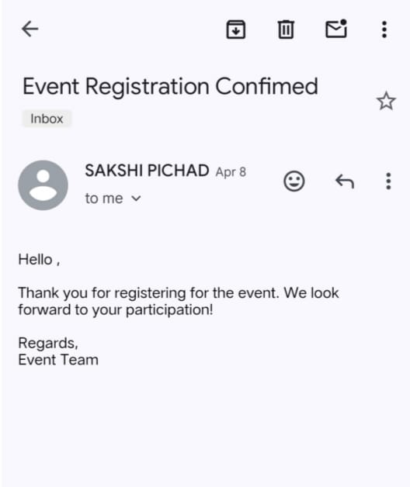

📌 Purpose: Enhances user experience by keeping students informed instantly.

🔹 What Students Receive:
A confirmation email immediately after registering.
Email content includes:
🎟️ Event Name
🕒 Date & Time
📍 Venue / Location
✅ A “Thank You” confirmation message.

🔹 Behind the Scenes (Configuration):
Created an Email Template in Salesforce.
Used Flow Action → Send Email after registration record creation.
Email dynamically pulls details from the Event__c and Registration__c objects.
💡 Impact:
Students feel assured their registration is successful.
Reduces queries like “Did my registration go through?”
Adds professionalism to the system.
🔑 Key Highlights of the System
✅ 100% built using Salesforce Build (Declarative tools) → No Apex coding.
✅ Smooth Student Experience: Event browsing → Registration → Dashboard → Email confirmation.
✅ Efficient Admin Experience: Dashboards, analytics, and live data.
✅ Automation-Driven: Salesforce Flow handles linking & communication.
✅ Professional touch with real-time email notifications.

